**Chapter 23 Programming Assignment**

By Reno Redaja

**Project 23.1**

Write a program that implements the following generic method using the bubble sort:

public static <E extends Comparable<E>> void bubbleSort(E[] list)

Section 23.3 Bubble Sort gives you the algorithm and a sample implementation using an array of ints. For this project, you will use the Comparable interface to sort a generic list.

In your main method, include at least two calls to your bubbleSort() method using two different types of objects (for example integers and strings).

Either in the **Answer box** or in a separate document/piece of paper, trace the sort for one of your examples (one of your original lists in your main() method). You can scan in or take a picture of your trace if you decide to write it out on paper.

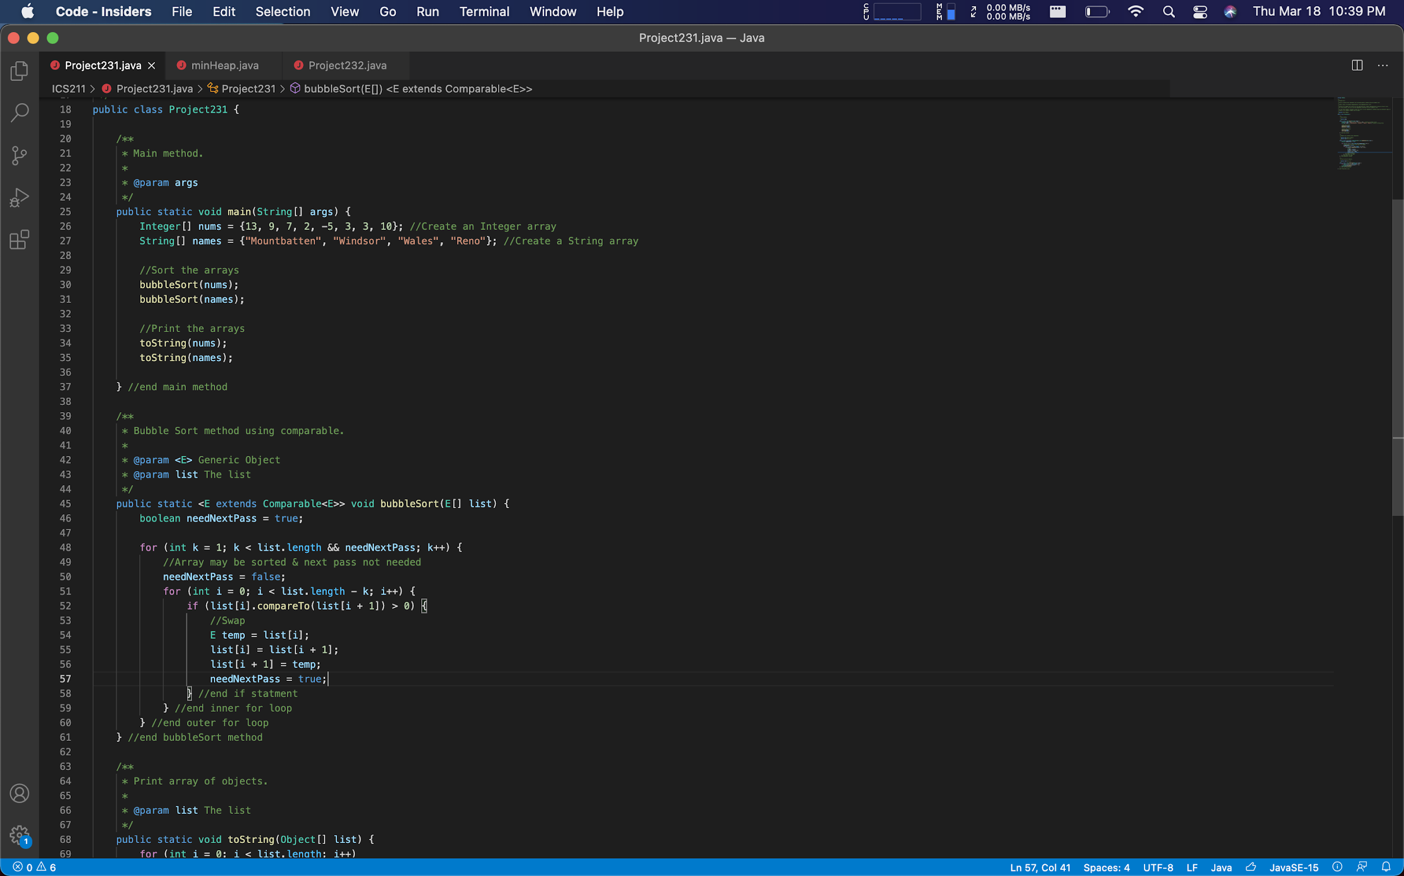

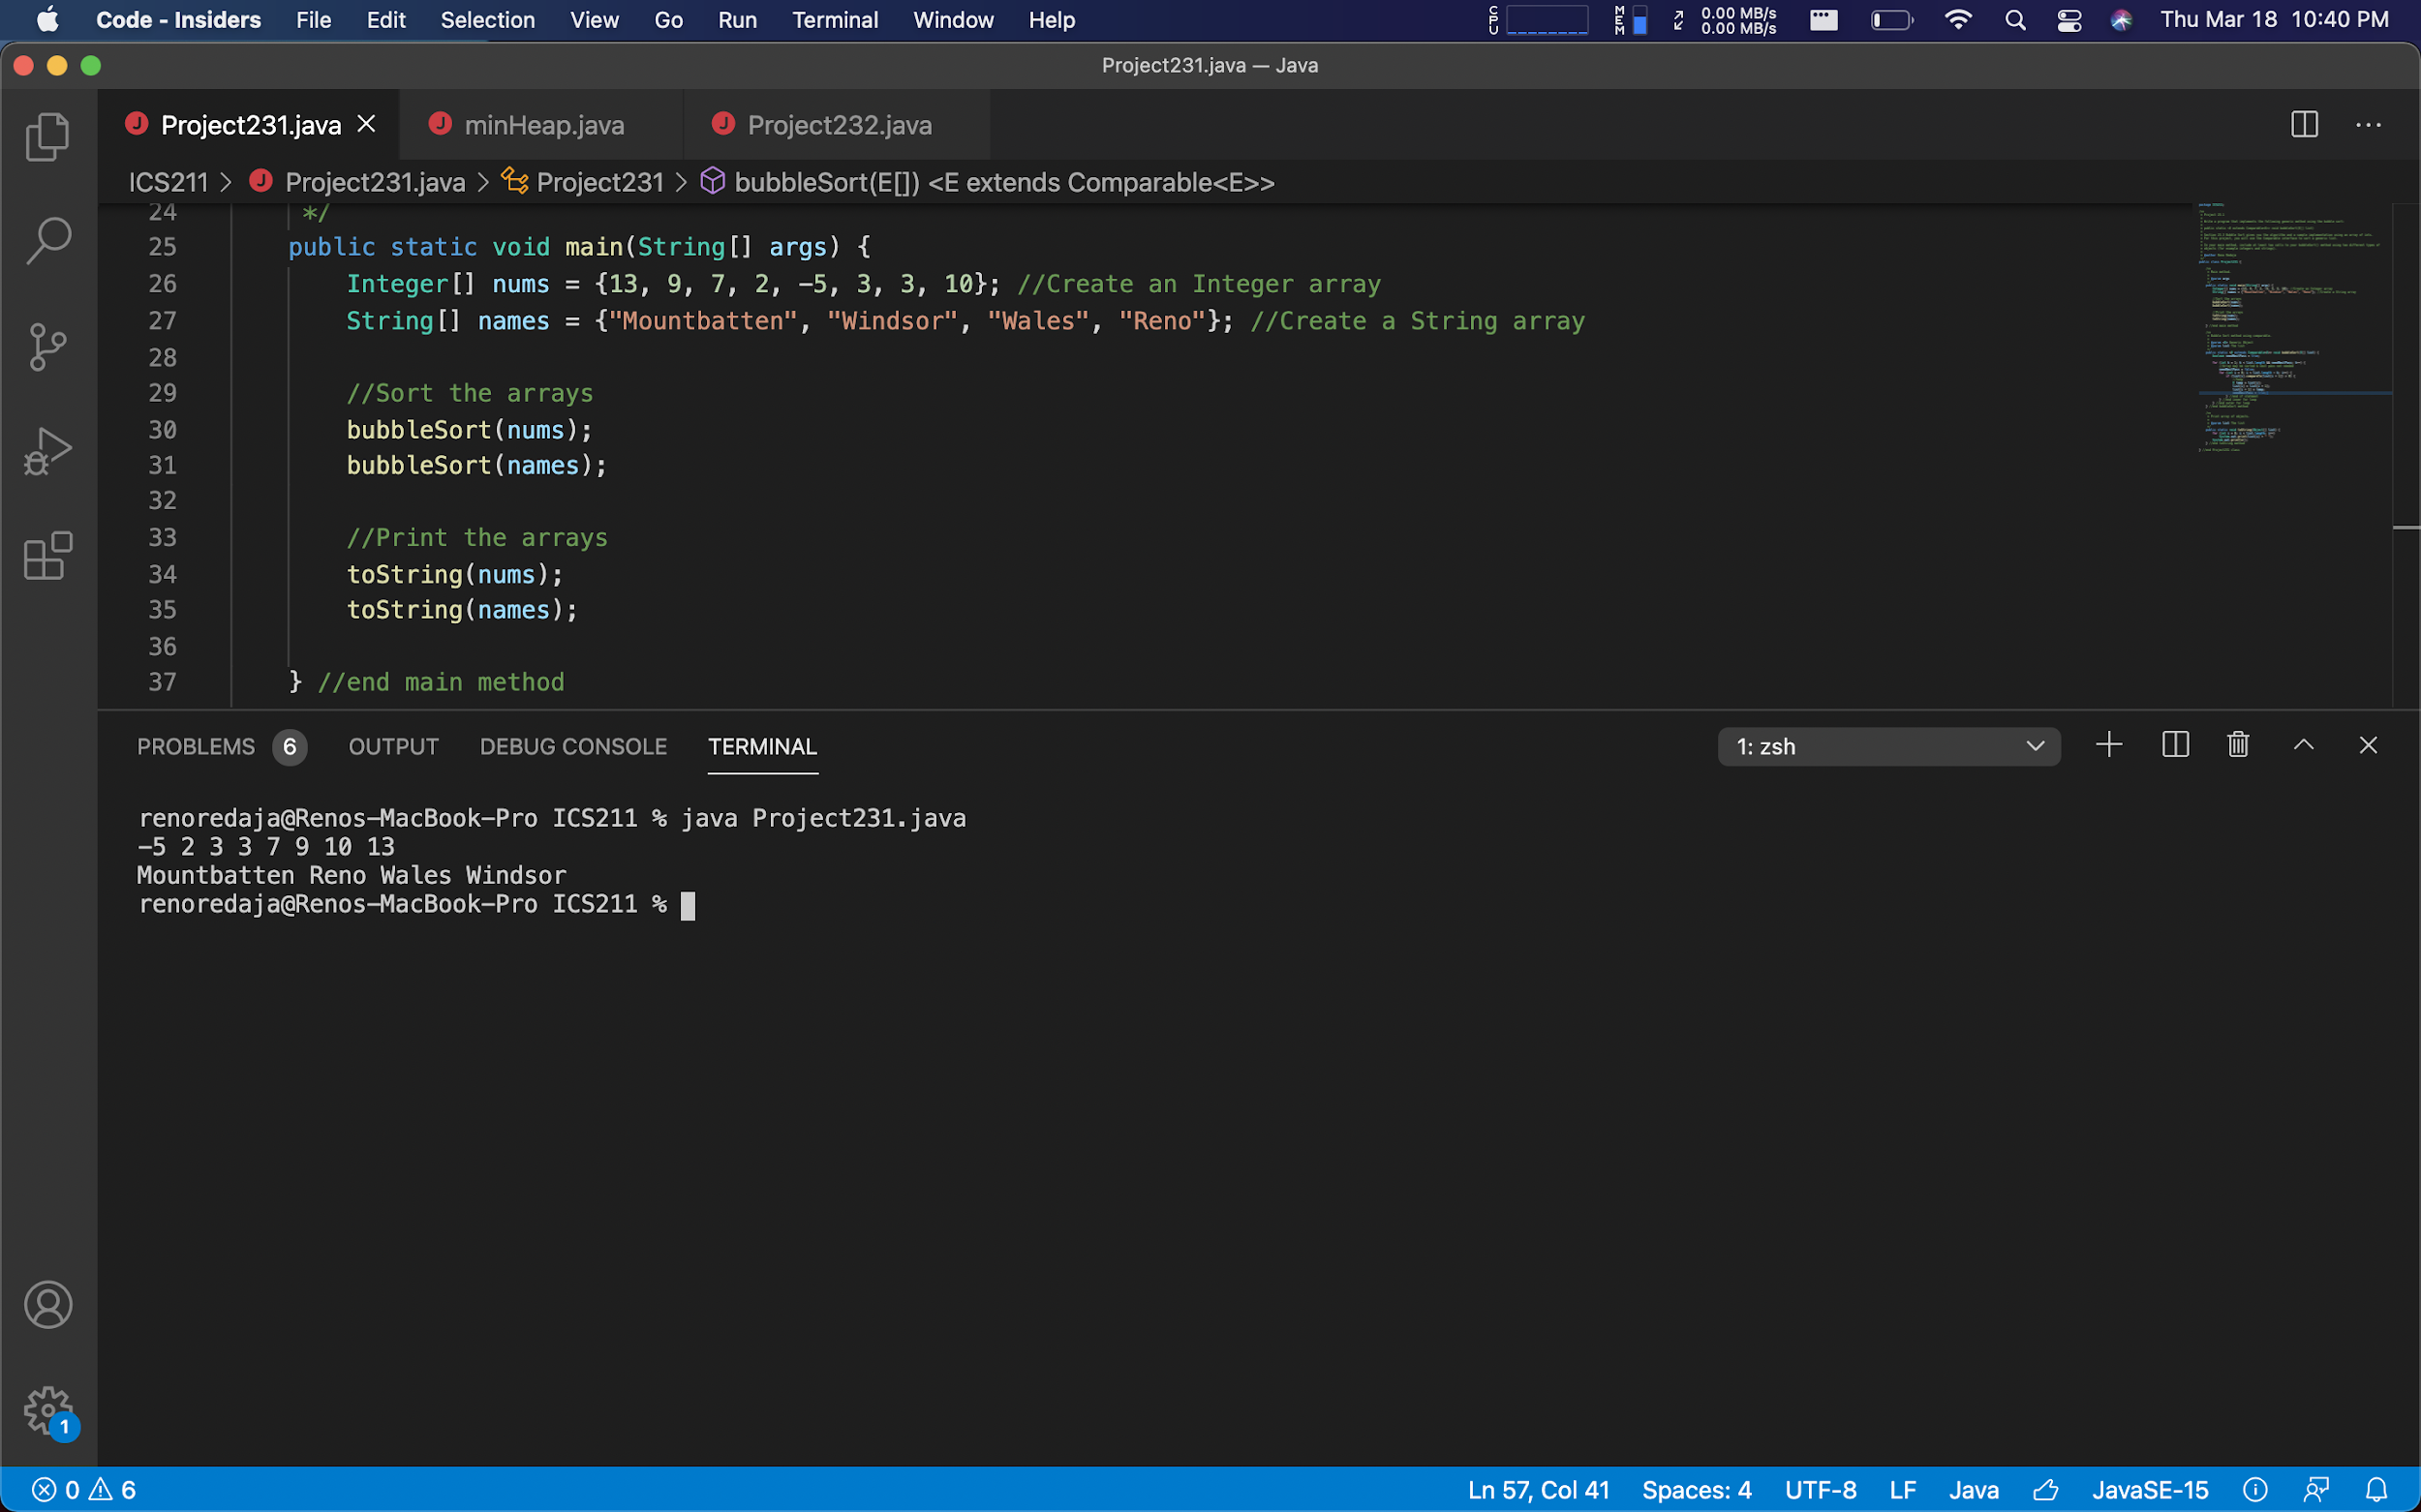

My program meets Project 23.1 requirements because it answers the prompt correctly. Within my program I have implemented a generic bubble sort method using an array of integers. In the main method it calls the bubble sort twice sorting integers & strings.

**Project 23.2**

Starting from the code in LiveExample 23.9 (Heap.java), revise the implementation so that it is a min-heap rather than a max-heap. A max-heap, as shown in this example, is a heap in which each node is greater than or equal to any of its children. A min-heap is a heap in which each node is less than or equal to any of its children. Min-heaps are often used to implement priority queues.

Once you have revised the Heap class, create a Test/Demo class that tests/demonstrates your implementation, with at least 10 elements. See LiveExample 23.10 (HeapSort.java) for an example of what your Test/Demo class might look like.

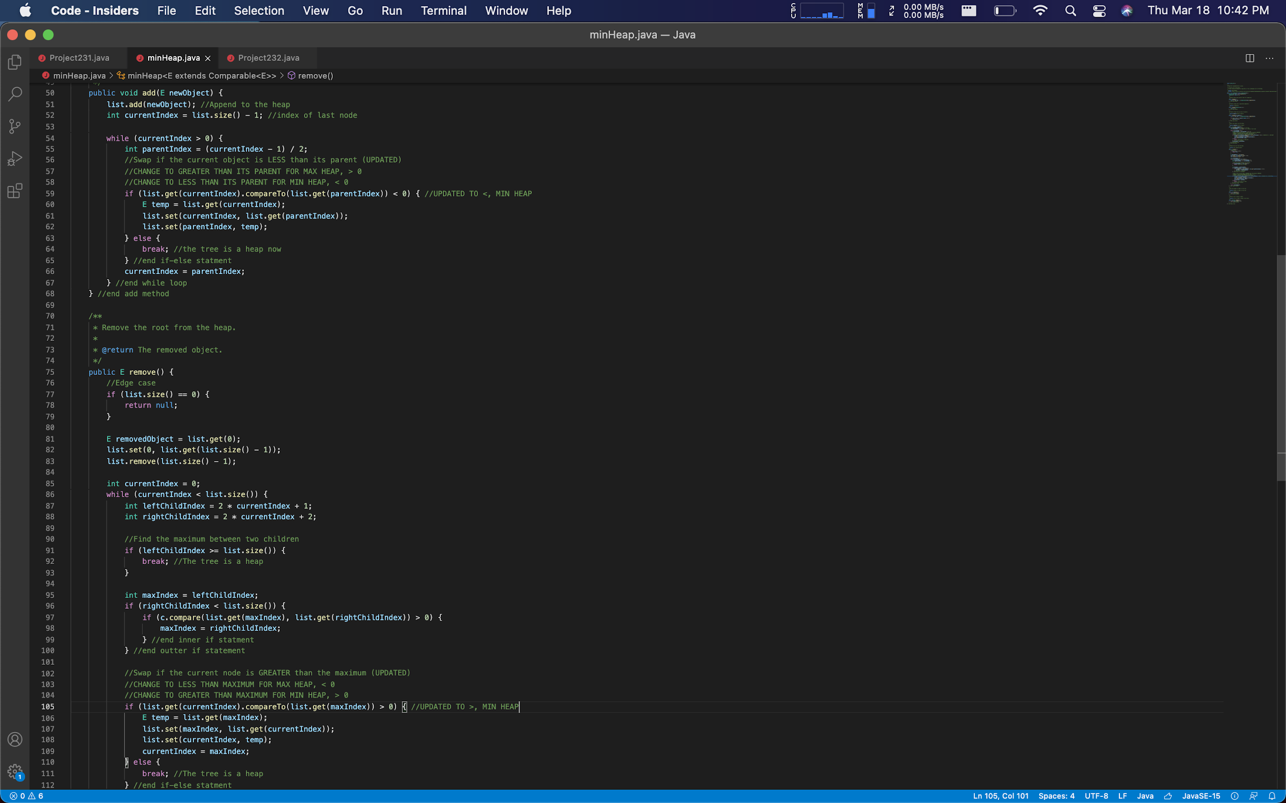

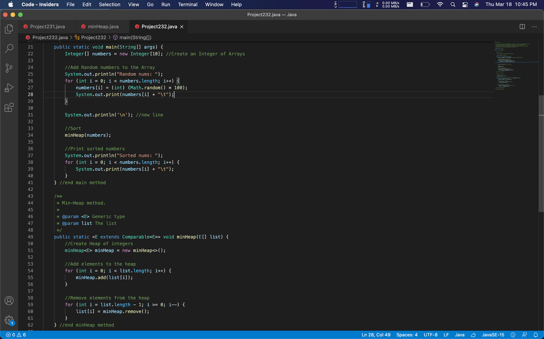

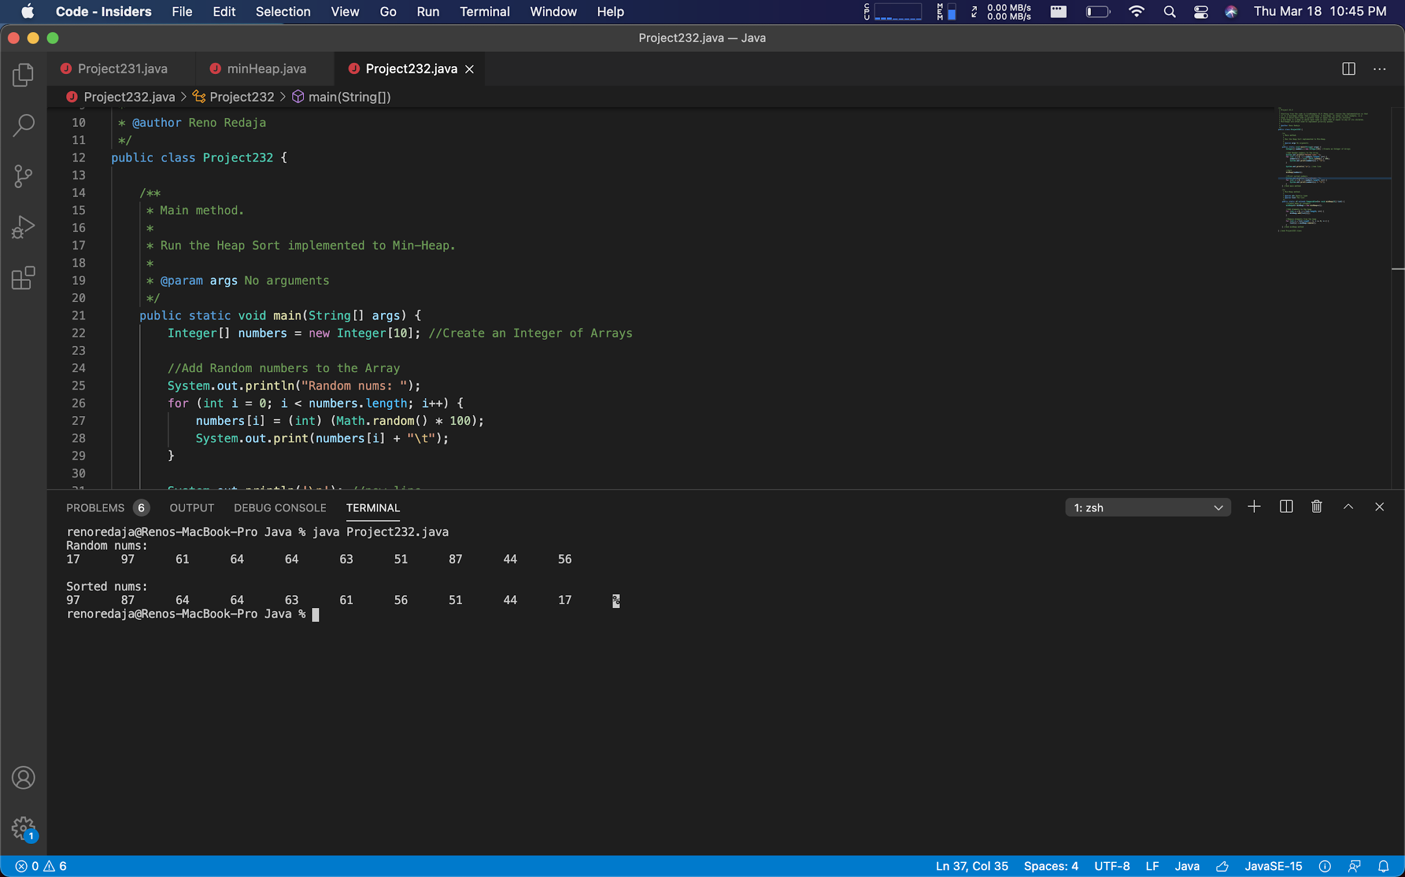

My program meets Project 23.2 requirements because it answers the prompt correctly. I have revised the implementation of the heap class within the textbook. It is now able to obtain the min-heap which each node is less than or equal to any of its children. Within the Project232.java I have called minHeap class to create a minHeap() method. The main method creates an Array of integers. Afterwards store the random integers into the array, call the minHeap() method, then sort the array.